David Parrish
Helping creative entrepreneurs world-wide to become even more successful

David Parrish
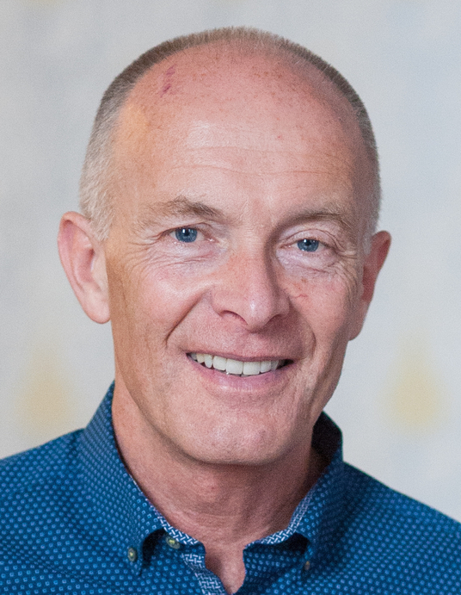
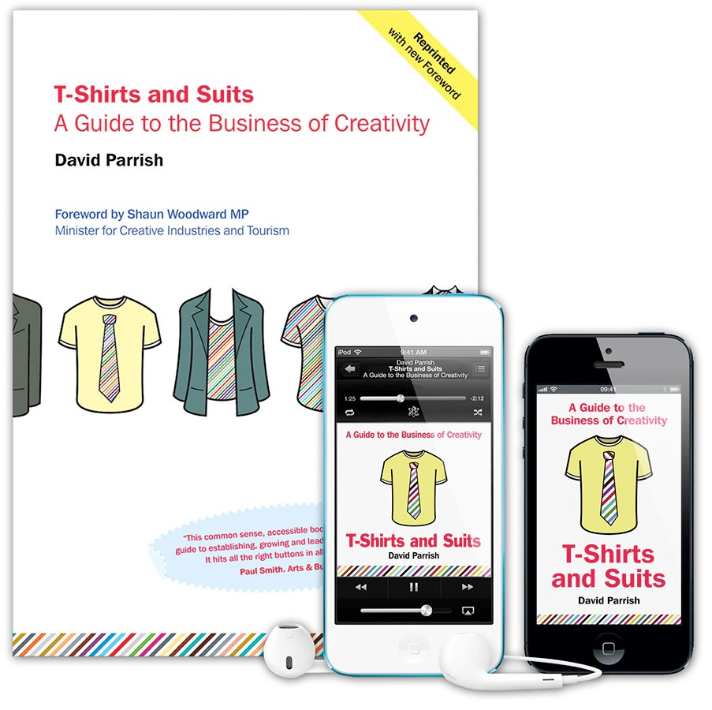

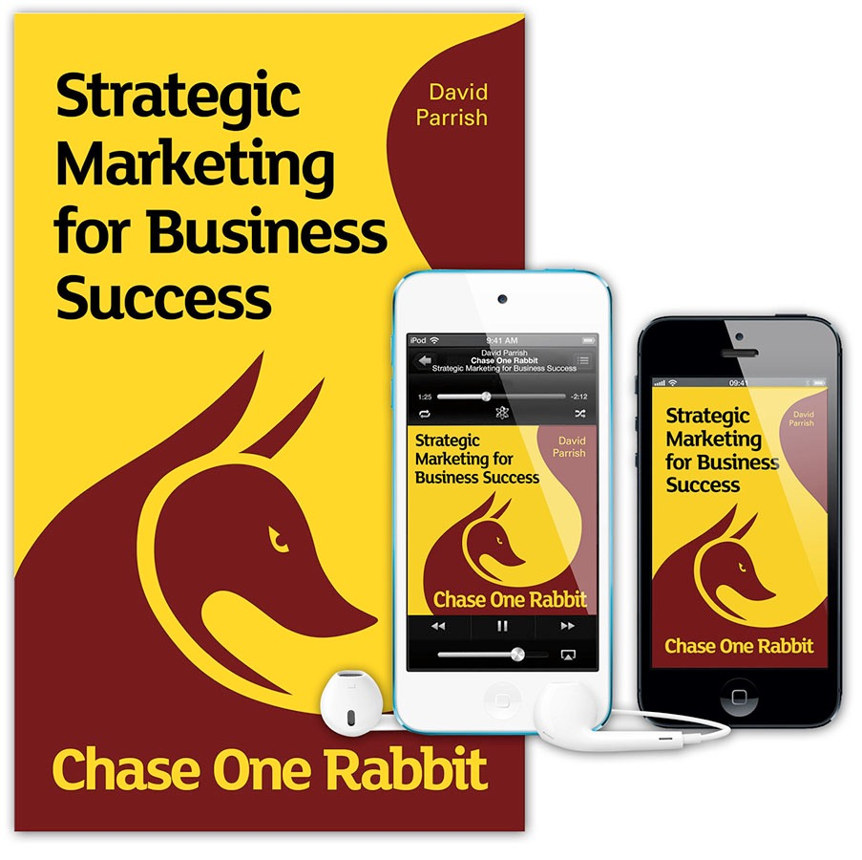

David helps creative entrepreneurs make their businesses and organisations even more successful. He works internationally as a speaker, trainer and consultant specialising in the creative, digital and cultural sectors.

David has set up and managed enterprises in the creative industries throughout his career as an entrepreneur.

After learning about business primarily from practical experience, he later went to business school, graduating with a Masters Degree in Business Administration (MBA), ‘with distinction’, from Bradford University Management Centre, one of Europe’s leading business schools.

David speaks about creativity and business at conferences and creative industries events world-wide.
His management consultancy clients include high-growth businesses in the creative and digital sector, creative industries support agencies and specialist business development projects world-wide. As a trainer he designs and delivers interactive workshops on marketing, strategic planning, finance, business growth, leadership and management, pricing, change management and
intellectual property.

David is author of the highly-acclaimed book and eBook
'T-Shirts and Suits: A Guide to the Business of Creativity'. His approach to business development combines creative people ["T-Shirts"] with smart business thinking ["Suits"].
The book has also been published in China, Colombia, Taiwan, Spain, Lithuania, Thailand, Chile, Ukraine,
Belarus and Moldova.

HIs latest book on strategic marketing is 'Chase One Rabbit: Strategic Marketing for Business Success. 63 Tips, Techniques and Tips for Creative Entrepreneurs’.

David has worked in 50+ countries: Azerbaijan, Belarus, Belgium, Bosnia & Herzegovina, Brazil, Bulgaria, Canada, Chile, China, Colombia, Croatia, Denmark, Egypt, Estonia, Finland, France, Georgia, Germany, Holland, India, Indonesia, Ireland, Italy, Jamaica, Korea (South), Kosovo, Laos, Lithuania, Malaysia, Moldova, Morocco, New Zealand, Norway, the Philippines, Portugal, Romania, Russia, Saudi Arabia, Serbia, Singapore, South Africa, Spain, Sweden, Switzerland, Taiwan, Thailand, Turkey, Ukraine, the United Arab Emirates, USA, Vietnam, Zimbabwe and the UK.

He is a Fellow of the Chartered Institute of Marketing and a ‘Chartered Marketer’, a Fellow of the Institute of Consulting, a Fellow of the Institute of Leadership and Management, and a Fellow of the Royal Society of Arts.

Some examples of his work include:

- Keynote Speaker at Festival Naranja 2017, the creative industries (“Orange Economy”) event in Colombia.

- Creative Industries Speech at Local Enterprise Week 2017 in County Donegal, Republic of Ireland.

- Keynote Speaker at the Ejadah Creative Economy Conference and Exhibition in Saudi Arabia.

- Giving presentations and workshops in Vietnam, Taiwan, Chile, Zimbabwe, Brazil, Lithuania, the Philippines, China, Ukraine, Georgia, Belarus and Azerbaijan with
the British Council.

- Advising Brazilian creative enterprises at events in Rio de Janeiro, São Paulo, Nova Friburgo and Cuiabá.

- Speaker at the World Summit of Creative Industries in Moscow, at the Global Entrepreneurship Congress 2014.

- Keynote speaker at the Korea Creative Economy Forum.

- Guest speaker at the Creative Business Cup International Finals in Copenhagen, Denmark.

- Guest speaker in Moscow at Summer School for Russian creative entrepreneurs.

- Keynote Speaker in Ukraine at the Business Wisdom Summit in Kiev, 2015

- Speaking at TEDxNapoli on Crisis and Creativity.
Cool business ideas, networks, videos, books and free stuff;
www.davidparrish.com

